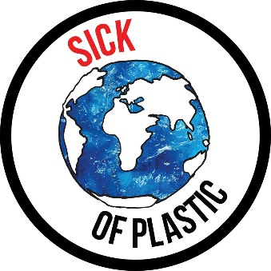

Sick of Plastic Local Groups Communications Toolkit
How to amplify your actions using social media!

Sick of Plastic is a national campaign being led by Friends of the Earth and VOICE Ireland to empower communities to take action on single use plastics.

Despite introducing the plastic bag tax back in 2002, we’re taking more plastic packaging home (in our reusable shopping bags) than ever! We need to put pressure on supermarkets and decision makers to eliminate unnecessary plastic.

Personal Change vs System Change

Personal change is great but isn’t enough, it shouldn’t be up to the consumer to make better choices when those choices are not always available or affordable.

In many cases, buying loose fruit and veg is more expensive than buying produce wrapped in plastic.

Not all supermarkets are offering plastic free – but they should.

We need those responsible for creating plastic waste to take action!

Soft Plastics are not Recyclable

Soft plastics cannot be recycled in Ireland, most of the plastic we bring home from the supermarket cannot go into the household recycling bin. This plastic was designed for one short use, and will go straight to landfill or incineration from your general waste bin.

Soft plastic needs to be eliminated. Where packaging is necessary, recyclable or compostable materials should be used instead.

What can supermarkets do?

- Offer more items without packaging, such as fruit and vegetables (without plastic trays, wrapping and nets).
- Make your own-brand packaging easily compostable or recyclable, and use less plastic.
- Demand, through your purchasing power, that other brands you carry have easily compostable or recyclable packaging, and use less plastic.
- Blaze a trail in Ireland by implementing a plastic free aisle, as has been done in the Netherlands.
- Provide items in bulk, where possible, to reduce packaging.
- Allow shoppers use their own containers, buying only what they need.

Posting on Social Media

Use these hastags in your social media posts:

#SickOfPlastic #ShopAndDrop #BreakFreeFromPlastic

And tag our pages so we can share your posts too:

Sick of Plastic
Instagram: @sickofplasticireland
Twitter: @SickOfPlasticIE
Facebook: @sickofplasticireland

Friends of the Earth
Instagram: @friendsoftheearthireland
Twitter: @foeireland
Facebook: @foeireland

VOICE Ireland
Instagram: @voiceireland
Twitter: @voiceireland
Facebook: @voice_ireland

Here are some example messages to share on your social media platforms;

“I’m #SickOfPlastic and I want my local supermarket to #BreakFreeFromPlastic! Join our #ShopAndDrop day of action on April 13th at (insert your local supermarket) at (insert time). Join our local page and get involved (insert link to your ChangeX page)”

“(insert supermarket) we need you on board - let’s cut out the unnecessary plastic packaging and #BreakFreeFromPlastic!”

“Let's keep up the pressure on Supermarkets - it’s time they took shopper’s demands seriously. Join our #ShopAndDrop day of action (insert action details)”

“Best of luck to everyone joining the #ShopAndDrop action on supermarket plastic packaging today! Let’s #BreakFreeFromPlastic!”

“Are you #SickOfPlastic? Sign the @SickfOfPlastic petition to demand action from supermarkets and government. It’s time to #BreakFreeFromPlastic”

Top Tips:

- Tag the Sick of Plastic Ireland campaign in any posts you are sharing @sickofplasticireland
- If you are an organiser, create an event page for your local supermarket action and send it to us on FaceBook or email sickofplasticireland@gmail.com so we can share it!
- Be creative, use your own voice and create your own content!
- Take photos of products unnecessarily wrapped in plastic in your supermarket, and post it on your social media.
- Take photos of plastic wrapping that you take home and cannot recycle, and post it on your social media.
- Take photos of plastic waste found on streets, in parks and on beaches, and post it on your social media.
- Make sure you get verbal permission from people before taking their photo and posting it publically on social media.

Links to share:

Video from last year’s national Shop and Drop day of action: https://www.facebook.com/voiceireland.org/videos/10155216357605836/

Sick of Plastic petition: https://www.foe.ie/takeaction/break-free-from-plastic/

Plastic ‘Naked truths’ – facts about plastic and infographics:
https://www.foe.ie/news/2018/09/01/break-free-from-plastics-naked-truths/

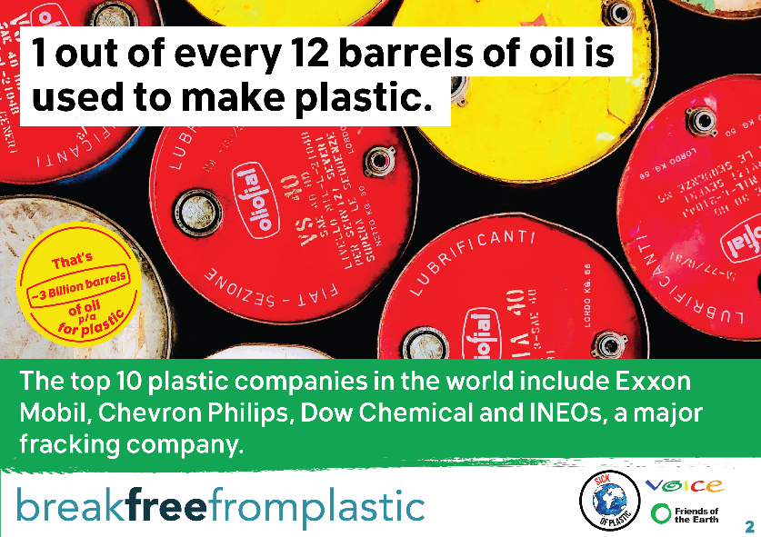
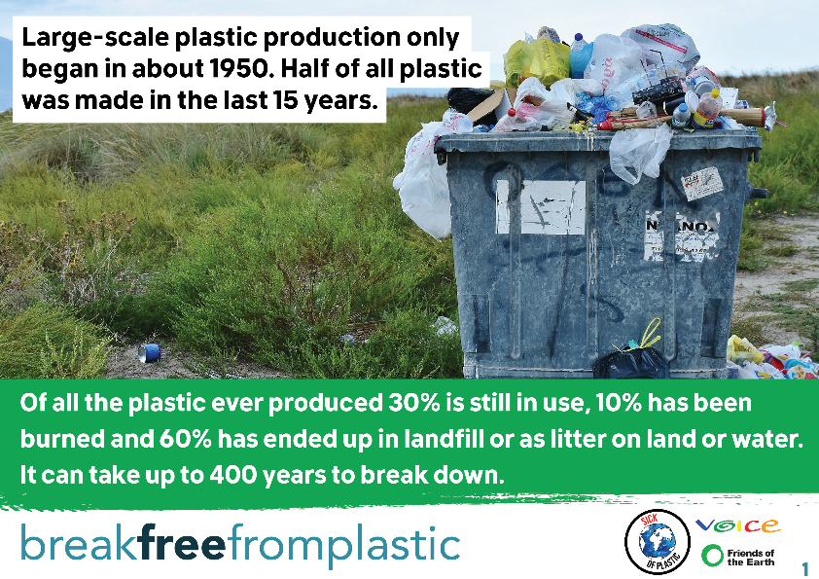

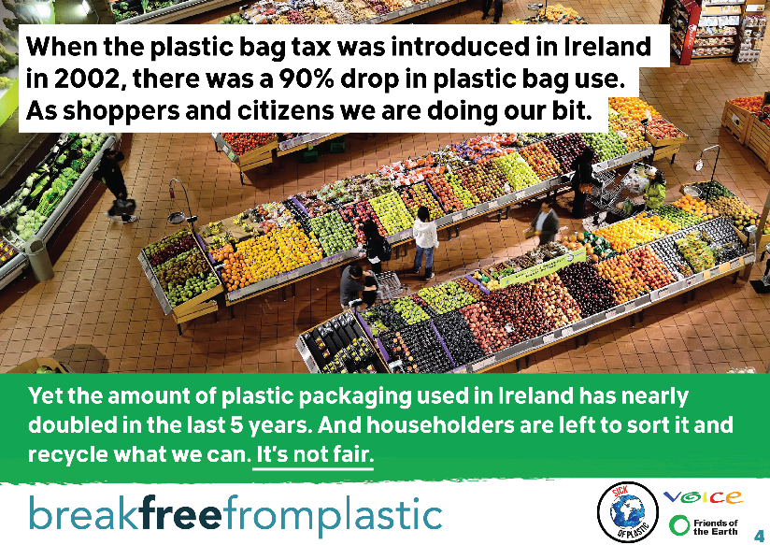
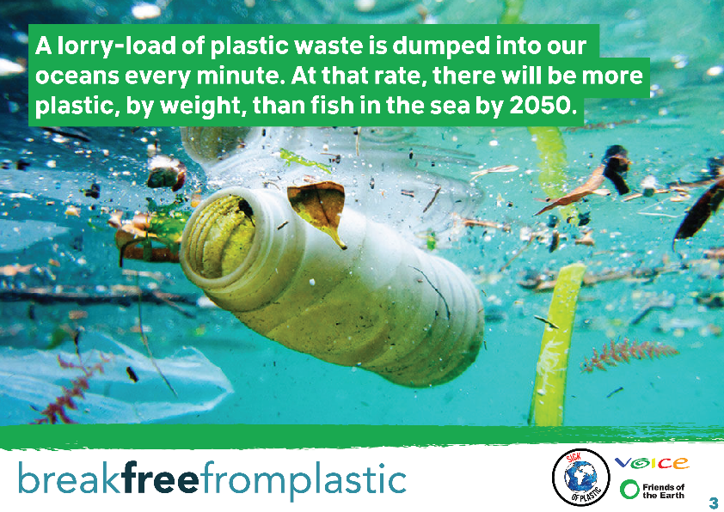

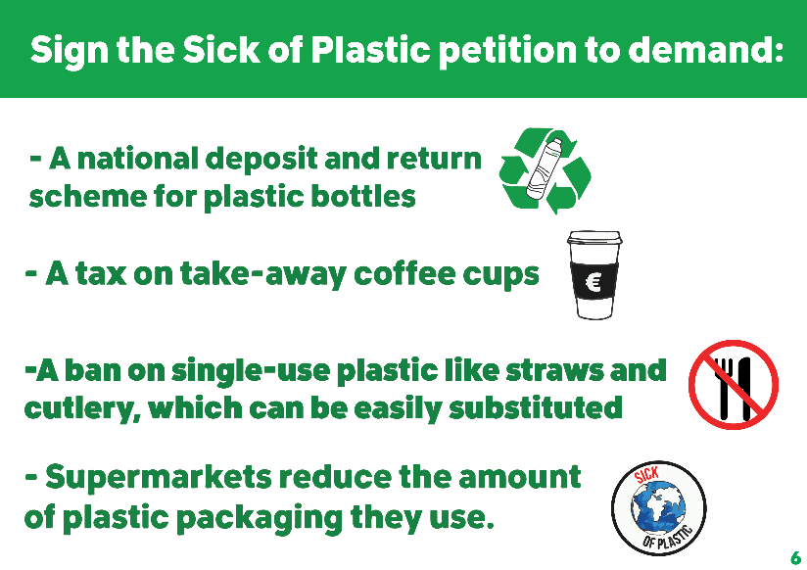
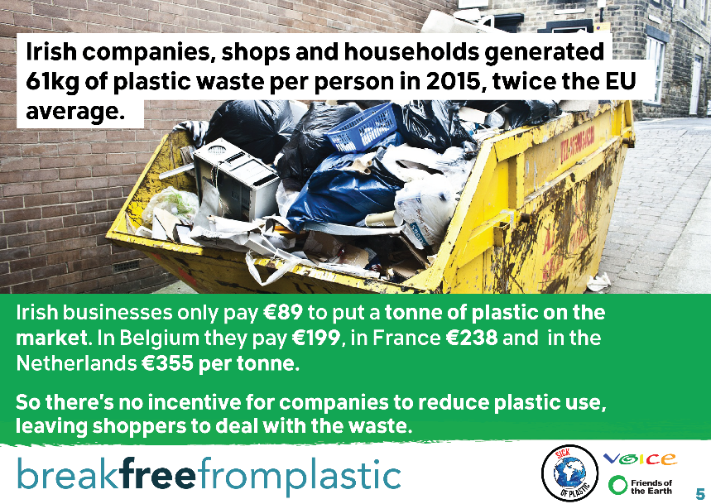

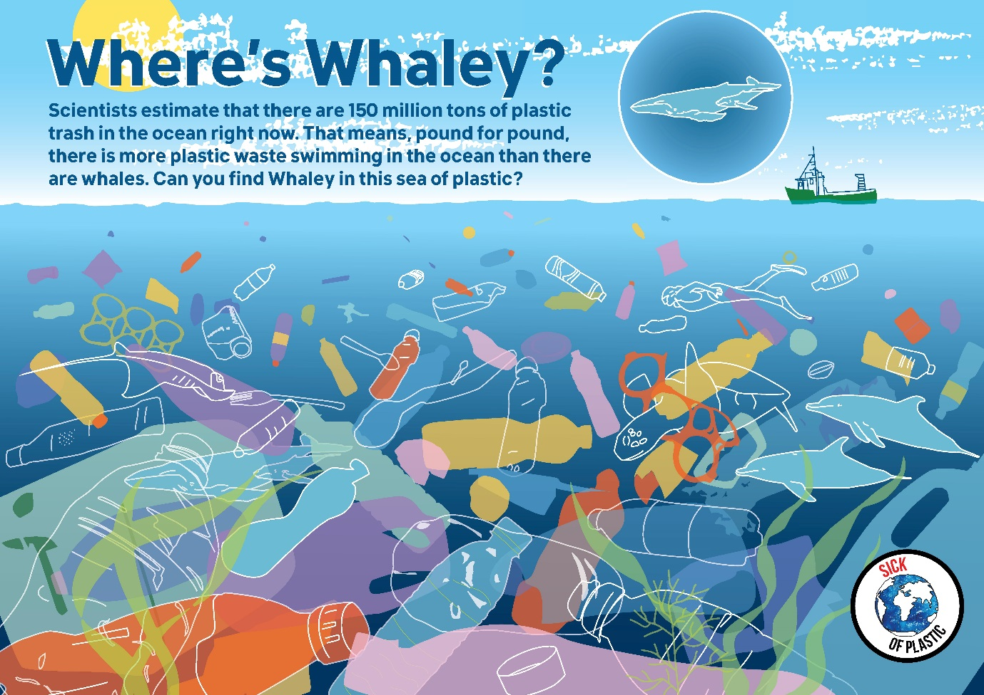

Break Free From Plastic infographics: https://www.breakfreefromplastic.org/infographics/

